

HURRICANE KATRINA SITUATION REPORT

September 5, 2005, 0800 HOURS PST
Page 1 of 4

I. Situation Summary:

- The Coast Guard reports that over 22,785 survivors have been rescued so far. 9,400 patients have been evacuated from area hospitals.

- Federal officials chartered three Carnival Cruise Lines ships for six months to provide shelter for Hurricane Katrina evacuees. Two of these cruise ships will deploy to Galveston and will be used for elderly care and people with special needs. The third ship is scheduled to arrive in Mobile, Ala. on Thursday, Sept. 8, to begin lodging about 1,800 displaced persons.

- Seven Disaster Recovery Centers (DRCs) are now operational (6 in Alabama; 1 in Texas).

- 34,845 National Guard members from 42 states are currently deployed. 36,245 are anticipated to be in place by September 6.

- Chief Naval Operations (CNO) approved a waiver for civilian helicopter operations on board USN amphibious ships in support of relief operations.

- The USS BATAAN is in the region and is ready to begin accepting patients.

- The Department of Defense will be standing down air operations today. Ground support will continue and cargo support is increasing.

- 1 destroyer and 2 frigates by Canadian Navy are expected to arrive on September 10 to assist as needed.

- England has offered aircraft and 1,100 tons of meals-ready-to-eat.

- The Department of Transportation is coordinating pharmaceutical shipments from the Netherlands and Canada.

- The official death toll remains at 325.

- A total of 59 corpses have so far been recovered in New Orleans, officials said overnight, cautioning that the first official death toll from Hurricane Katrina was just a fraction of those killed. "The number of deceased victims that we will report today, is only a starting point, it is a small number that everyone of us knows is going to grow," said Dr. Fred Cerise, Louisiana Health and Hospitals Secretary.

- A total of 466 public water systems (serving 1.2 million people) have been negatively impacted and are not operating normally.

- A major oil spill into the Mississippi River was reported 30 miles south of New Orleans.

- An anhydrous ammonia leak occurred from an estimated 25,000 ton tank in the Bayou Casotte area of Pascagoula, MS. Evacuations were underway in the area, however, the situation has been stabilized to the point that further evacuation efforts have been suspended.

- The national preparedness increased to level 4 on September 1 in recognition of current and predicted support to Hurricane Katrina. National Preparedness Level 4 means two or more geographic areas are experiencing incidents requiring Type 1 Teams. There is also competition for resources between geographic areas. Preparedness Level 4 may also mean 425 crews or five Type 1Teams are committed nationally.

HURRICANE KATRINA SITUATION REPORT

September 5, 2005, 0800 HOURS PST
Page 2 of 4

- The number of evacuees by state: Alabama – 10,000; Arkansas – 50,000; Colorado – 2,000; Florida – 1,100; Georgia – 1,000; Illinois – 500; Louisiana – 50,000; Michigan – 500; Mississippi – 12,500; Missouri – 500; Oklahoma – 5, 000; Tennessee – 12,000; Texas – 127,000; Utah – 200; West Virginia – 500; Washington, DC – 400. Total – 274,100.

In addition, Arizona, Indiana, Iowa, Maryland, Massachusetts, Minnesota, South Carolina, Montana, Nevada,
North Carolina, Ohio, and Oregon have all volunteered to accept evacuees.

Reported Yesterday:

- A Eurocopter AS 332 Super Puma helicopter crashed northwest of downtown New Orleans Sunday evening. The pilot and crew sustained minor injuries and were rescued by the Coast Guard.

- FEMA has set up a Donations Hotline at 800-440-6728.

- According to the Louisiana Department of Social Services, a phone number has been set up for help in locating missing children: 1800-thelost and a Web site as well: http://www.missingkids.com

- Katrina Missing Persons Hotline, 1-888-544-5475, will go live at 12:00 Noon (Eastern) on Monday, September 5.

- CNN has developed a service to allow refugees and others affected by the hurricane to post their name and let others know that they are safe. The site is located at: http://www.cnn.com/SPECIALS/2005/hurricanes/list/

- Health care professionals and relief personnel that wish to volunteer to assist with Katrina response operations can do so online. The web site is located at: http://www.hhs.gov/emergency/hurricane.html

II. Weather Forecast:

 | Mon | Tue | Wed | Thu
General | Isolated Thunderstorms |  |  | Mostly Sunny
High/Low | 92°/74° | 90°/73° | 91°/72° | 91°/73°
Precip. Chance | 30% | 30% | 30% | 30%

Hurricane Maria continues to become better organized and slowly strengthen. Little wind shear and warm waters have aided in Maria’s intensification as current sustained winds are now 90mph. Maria is located several hundred miles east of Bermuda and thankfully is forecast to move north and eventually to the northeast making no impact on the United States.

III. Current Actions:

CATF-1 (Team 3 – Swift Water Rescue) worked a full operational period yesterday (Sunday). They were airlifted to the same isolated area that they worked on Saturday. Their work was primarily humanitarian in nature. Many of the areas in this sector were only under one foot of water. Therefore, they commandeered a forklift, dump truck, and a fire truck to move about more easily. This enabled them to deliver meals-ready-to-eat and water to many of the residents that are still stranded in this area of Louisiana. They are still accompanied by DEA Agents that provide force protection, but no incidents of hostility were encountered.

Morale remains high, no injuries or illnesses have been reported, and they are now receiving full logistical support (showers, hot meals, decon, etc.).

CATF-1 (USAR) received deployment orders last night. They are en route to Gulfport Mississippi, approximately 580 miles from Dallas, where they will be assigned to work.

LAFD’s Battalion Richard Warford, as part of an Incident Management Team, has been assigned to the FEMA Program Office in Washington DC. He will assist FEMA management personnel in overseeing response and recovery efforts throughout the region.

HURRICANE KATRINA SITUATION REPORT

September 5, 2005, 0800 HOURS PST
Page 3 of 4

LAFD’s Battalion Chief Mark Saxelby and Captain Wade White, as part of an Incident Support Team, are currently deployed to Gulfport, Mississippi.

The map below illustrates the locations and designations of currently assigned USAR assets.

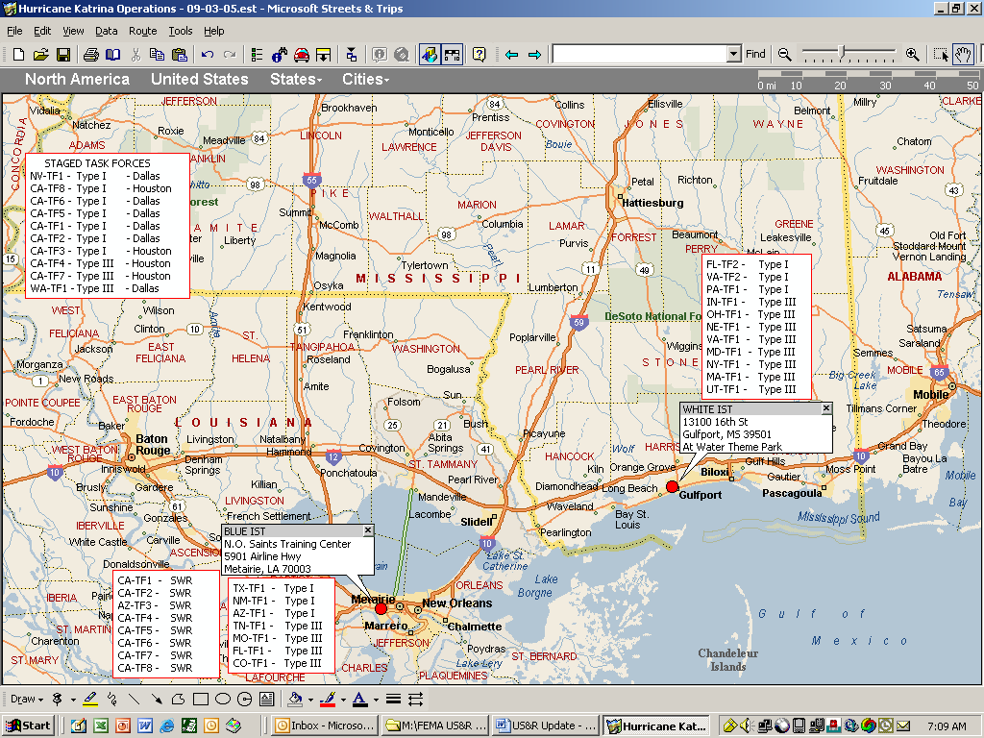

Reported yesterday:

This incident marks the first deployment of Swift Water Rescue resources as part of a FEMA deployment.

The LAFD still has three USAR Task Forces (FS 88, FS 27, FS 85) available to handle local incidents, if needed.

The State of California has assessed in-state capabilities. There are sufficient resources to form USAR Task Forces to cope with local incidents.

100 California Highway Patrol Officers will be deployed to Louisiana.

HURRICANE KATRINA SITUATION REPORT

September 5, 2005, 0800 HOURS PST
Page 4 of 4

IV. Miscellaneous Important Information:

Fatalities (Confirmed): No current update available for this report.

Louisiana | Mississippi | Alabama | Florida | Texas | Total
126* | 185** | 2 | 11 | 1 | 325
*Estimates are in the thousands. **Estimates are in the hundreds.

Security:

Current members and number of federal law enforcement officers in the region: 1,548

Immigration and Customs Enforcement (ICE) - 333
Federal Air Marshall Service (FAMS) - 501
Federal Bureau of Investigation (FBI) - 200
Alcohol, Tobacco and Firearms (ATF) - 135
Drug Enforcement Administration (DEA) - 75
Customs and Border Protection (CBP) - 204 + 100 deploying

Electricity:

State | Customer without power | % of Total
Alabama | 74,002
Louisiana | 668,861
Mississippi | 511,514
Total | 1,254,377 | 33%

Some electric power plants in the New Orleans area are operational; power is being slowly restored in some
surrounding areas.

Communications:

Blimps, weather balloons, and other aircraft will be serving as cell towers to improve communications.

Three satellite vans are in the New Orleans area, and one is in Stennis, Mississippi.

Improved communications across the region are anticipated over the next 24-48 hours on a staggered
basis.

Shelters:

Combined voluntary and public shelter population in place or in transit is 274,100 in 15 states and the
District of Columbia.

Situation Report Prepared by LAFD Special Operations Division, Homeland Security Intelligence Section

